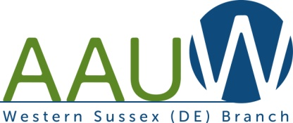
Western Sussex Branch AAUW Scholarship Offerings 2019
High School
Deadline: First Monday in April
Eligibility: Open to women attending high school in their senior year; who are residents of Laurel, Seaford, Woodbridge, or Delmar School Districts; who will be enrolled full-time in a four-year college in the United States; and who will be working toward a B.A. or B.S. degree. A minimum 3.0 GPA is required.
Award: Two, $1,000 scholarships awarded
Contact: Applications available from high school guidance office

Delaware Aerospace Academy Summer Camp
Deadline: May 15
Eligibility: A Seaford Middle School young woman enrolled in a science class. Selection based on interest, application, and recommendation of science teacher.
Award: Tuition to overnight Academy in July
Contact: Applications available from school science teacher.
Marcia L. Windley
6863 Atlanta Circle
Seaford, DE 19973
mlwindley@comcast.net

